Secure VPN & Cloud Storage
Functional Specification

Maciej Chudy / C00247467
Supervisor: Joseph Kehoe
Contents
Abstract 2
Introduction 4
Project Scope 4
FURPS 4
Functionality 4
Usability 4
Reliability 4
Performance 4
Supportability 4
Use Diagrams 5
Use-Case 5
Short-Case 5
Metrics 6

Introduction
In this functional specification document, I will go over the main factors of the project that will give us a clear understanding of the process that happens once a user initiates the connect process.

Project Scope
The purpose of this project is to set up a virtual server and have it run in the cloud through a server hosting provider and allow users to use a VPN to connect to the server from anywhere in the world and gain access to a wide variety of applications such as a text editor, live messaging, e-mail, and more.

FURPS+

Functionality
When the connect sequence starts, the user should firstly connect to a different server that will not be running on the SETU Carlow network, that server should then forward the connection to the virtual server running on the SETU network, this will make any traces of users connecting to the server hidden from the malicious user.

Usability
A user is more likely to use an application that is easy to use and learn, hence the usability of the applications running on the server is important. The applications must have a simple user interface that is clearly labelled and easy to understand while still being maintaining good performance without any delay.

Reliability
The server must be reliable so wherever a user is located and whenever they would like to access the data that they have on their server it must be possible without any delay and no down-time. The server must maintain functionality even during unexpected events.

Performance
The server must be capable of still running smoothly during a time that all users are connected and performing hardware intensive tasks in order to maintain reliability, usability, and functionality at all times.

Supportability
No matter what device a user is using, they should be able to connect to the server using a VPN and access their data without any issues.

+ (Security)
From the moment a user first initiates some sort of contact with the server, the user’s packets that are being sent will be fully encrypted and will continue to be encrypted until the user fully disconnects as well as some other safety features such as a kill switch that will immediately disconnect a user if their internet connection were to be interrupted causing a loss of connection.

Use Diagrams

Use-Case

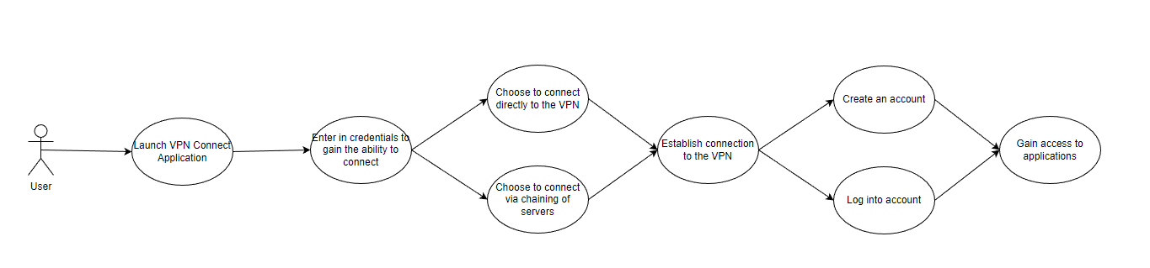

Short-Case
No. | Action | Precondition | Output
1 | Connect to VPN |  | -User gains ability to connect to server  -User gains access to website
2 | Log in through pre-determined credentials |  | -User gains access to interface
3 | Select which application to use | -Must be connected to the server through the VPN  -Must have entered credentials beforehand | -Redirected to webpage running selected application

Metrics
At the end of the project, I will count it as a successful project if the following criteria are met.
- I have successfully created a VPN connect program that runs both on Windows and Linux.
- The server chaining functionality works flawlessly.
- A user who connects to the server is protected from the moment the first connection is established.
- The server offers similar functional applications compared to a regular work machine that uses Office365.
- Offer other features like a password manager and a whole server monitoring dashboard.

